SPLIT FILE OFF.
EXAMINE VARIABLES=trvtime_cbd_bsas BY COVERAGE_TYPE
/PLOT=BOXPLOT
/STATISTICS=NONE
/NOTOTAL
/ID=CODIGO_TXT.

Explore

Notes
Output Created |  | 13-MAR-2018 16:48:16
Comments
Input | Data | E:\Data_Final\3cases_traveltime.sav
Input | Active Dataset | DataSet1
Input | Filter | <none>
Input | Weight | <none>
Input | Split File | <none>
Input | N of Rows in Working Data File | 284
Missing Value Handling | Definition of Missing | User-defined missing values for dependent variables are treated as missing.
Missing Value Handling | Cases Used | Statistics are based on cases with no missing values for any dependent variable or factor used.
Syntax |  | EXAMINE VARIABLES=trvtime_cbd_bsas BY COVERAGE_TYPE  /PLOT=BOXPLOT  /STATISTICS=NONE  /NOTOTAL  /ID=CODIGO_TXT.
Resources | Processor Time | 00:00:03.73
Resources | Elapsed Time | 00:00:01.06

COVERAGE_TYPE

Case Processing Summary
 | COVERAGE_TYPE | Cases
 | COVERAGE_TYPE | Valid |  | Missing |  | Total
 | COVERAGE_TYPE | N | Percent | N | Percent | N
trvtime_cbd_bsas | MAJ | 50 | 96.2% | 2 | 3.8% | 52
trvtime_cbd_bsas | MIN | 84 | 93.3% | 6 | 6.7% | 90
trvtime_cbd_bsas | NONE | 136 | 95.8% | 6 | 4.2% | 142

Case Processing Summary
 | COVERAGE_TYPE | Cases
 | COVERAGE_TYPE | Total
 | COVERAGE_TYPE | Percent
trvtime_cbd_bsas | MAJ | 100.0%
trvtime_cbd_bsas | MIN | 100.0%
trvtime_cbd_bsas | NONE | 100.0%

trvtime_cbd_bsas

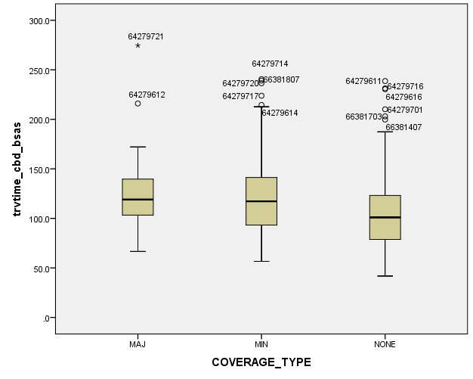

EXAMINE VARIABLES=trvtime_cbd_loc BY COVERAGE_TYPE
/PLOT=BOXPLOT
/STATISTICS=NONE
/NOTOTAL
/ID=CODIGO_TXT.

Explore

Notes
Output Created |  | 13-MAR-2018 16:48:56
Comments
Input | Data | E:\Data_Final\3cases_traveltime.sav
Input | Active Dataset | DataSet1
Input | Filter | <none>
Input | Weight | <none>
Input | Split File | <none>
Input | N of Rows in Working Data File | 284
Missing Value Handling | Definition of Missing | User-defined missing values for dependent variables are treated as missing.
Missing Value Handling | Cases Used | Statistics are based on cases with no missing values for any dependent variable or factor used.
Syntax |  | EXAMINE VARIABLES=trvtime_cbd_loc BY COVERAGE_TYPE  /PLOT=BOXPLOT  /STATISTICS=NONE  /NOTOTAL  /ID=CODIGO_TXT.
Resources | Processor Time | 00:00:00.64
Resources | Elapsed Time | 00:00:00.20

COVERAGE_TYPE

Case Processing Summary
 | COVERAGE_TYPE | Cases
 | COVERAGE_TYPE | Valid |  | Missing |  | Total
 | COVERAGE_TYPE | N | Percent | N | Percent | N
trvtime_cbd_loc | MAJ | 50 | 96.2% | 2 | 3.8% | 52
trvtime_cbd_loc | MIN | 85 | 94.4% | 5 | 5.6% | 90
trvtime_cbd_loc | NONE | 137 | 96.5% | 5 | 3.5% | 142

Case Processing Summary
 | COVERAGE_TYPE | Cases
 | COVERAGE_TYPE | Total
 | COVERAGE_TYPE | Percent
trvtime_cbd_loc | MAJ | 100.0%
trvtime_cbd_loc | MIN | 100.0%
trvtime_cbd_loc | NONE | 100.0%

trvtime_cbd_loc

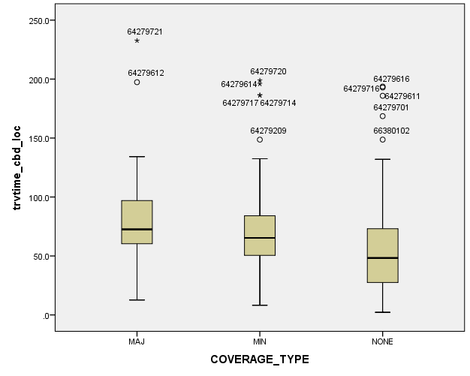

EXAMINE VARIABLES=trvtime_cbd_ngh_min BY COVERAGE_TYPE
/PLOT=BOXPLOT
/STATISTICS=NONE
/NOTOTAL
/ID=CODIGO_TXT.

Explore

Notes
Output Created |  | 13-MAR-2018 16:49:15
Comments
Input | Data | E:\Data_Final\3cases_traveltime.sav
Input | Active Dataset | DataSet1
Input | Filter | <none>
Input | Weight | <none>
Input | Split File | <none>
Input | N of Rows in Working Data File | 284
Missing Value Handling | Definition of Missing | User-defined missing values for dependent variables are treated as missing.
Missing Value Handling | Cases Used | Statistics are based on cases with no missing values for any dependent variable or factor used.
Syntax |  | EXAMINE VARIABLES=trvtime_cbd_ngh_min BY COVERAGE_TYPE  /PLOT=BOXPLOT  /STATISTICS=NONE  /NOTOTAL  /ID=CODIGO_TXT.
Resources | Processor Time | 00:00:00.34
Resources | Elapsed Time | 00:00:00.16

COVERAGE_TYPE

Case Processing Summary
 | COVERAGE_TYPE | Cases
 | COVERAGE_TYPE | Valid |  | Missing |  | Total
 | COVERAGE_TYPE | N | Percent | N | Percent | N
trvtime_cbd_ngh_min | MAJ | 50 | 96.2% | 2 | 3.8% | 52
trvtime_cbd_ngh_min | MIN | 85 | 94.4% | 5 | 5.6% | 90
trvtime_cbd_ngh_min | NONE | 137 | 96.5% | 5 | 3.5% | 142

Case Processing Summary
 | COVERAGE_TYPE | Cases
 | COVERAGE_TYPE | Total
 | COVERAGE_TYPE | Percent
trvtime_cbd_ngh_min | MAJ | 100.0%
trvtime_cbd_ngh_min | MIN | 100.0%
trvtime_cbd_ngh_min | NONE | 100.0%

trvtime_cbd_ngh_min

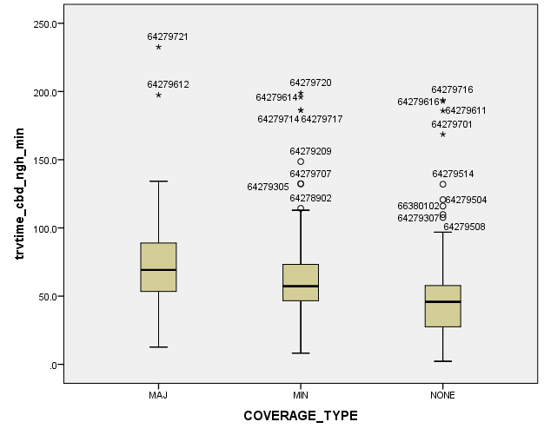

EXAMINE VARIABLES=trvtime_rail_min BY COVERAGE_TYPE
/PLOT=BOXPLOT
/STATISTICS=NONE
/NOTOTAL
/ID=CODIGO_TXT.

Explore

Notes
Output Created |  | 13-MAR-2018 16:49:31
Comments
Input | Data | E:\Data_Final\3cases_traveltime.sav
Input | Active Dataset | DataSet1
Input | Filter | <none>
Input | Weight | <none>
Input | Split File | <none>
Input | N of Rows in Working Data File | 284
Missing Value Handling | Definition of Missing | User-defined missing values for dependent variables are treated as missing.
Missing Value Handling | Cases Used | Statistics are based on cases with no missing values for any dependent variable or factor used.
Syntax |  | EXAMINE VARIABLES=trvtime_rail_min BY COVERAGE_TYPE  /PLOT=BOXPLOT  /STATISTICS=NONE  /NOTOTAL  /ID=CODIGO_TXT.
Resources | Processor Time | 00:00:00.34
Resources | Elapsed Time | 00:00:00.16

COVERAGE_TYPE

Case Processing Summary
 | COVERAGE_TYPE | Cases
 | COVERAGE_TYPE | Valid |  | Missing |  | Total
 | COVERAGE_TYPE | N | Percent | N | Percent | N
trvtime_rail_min | MAJ | 50 | 96.2% | 2 | 3.8% | 52
trvtime_rail_min | MIN | 86 | 95.6% | 4 | 4.4% | 90
trvtime_rail_min | NONE | 136 | 95.8% | 6 | 4.2% | 142

Case Processing Summary
 | COVERAGE_TYPE | Cases
 | COVERAGE_TYPE | Total
 | COVERAGE_TYPE | Percent
trvtime_rail_min | MAJ | 100.0%
trvtime_rail_min | MIN | 100.0%
trvtime_rail_min | NONE | 100.0%

trvtime_rail_min

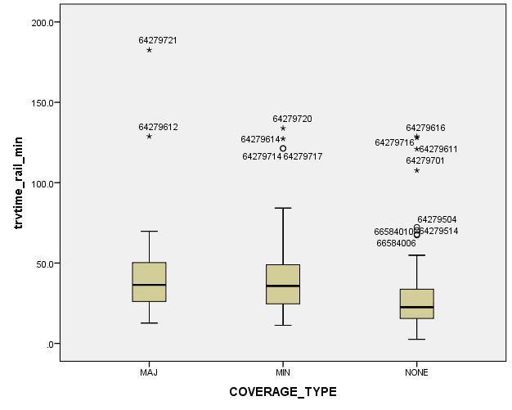

EXAMINE VARIABLES=trvtime_upa_min BY COVERAGE_TYPE
/PLOT=BOXPLOT
/STATISTICS=NONE
/NOTOTAL
/ID=CODIGO_TXT.

Explore

Notes
Output Created |  | 13-MAR-2018 16:49:45
Comments
Input | Data | E:\Data_Final\3cases_traveltime.sav
Input | Active Dataset | DataSet1
Input | Filter | <none>
Input | Weight | <none>
Input | Split File | <none>
Input | N of Rows in Working Data File | 284
Missing Value Handling | Definition of Missing | User-defined missing values for dependent variables are treated as missing.
Missing Value Handling | Cases Used | Statistics are based on cases with no missing values for any dependent variable or factor used.
Syntax |  | EXAMINE VARIABLES=trvtime_upa_min BY COVERAGE_TYPE  /PLOT=BOXPLOT  /STATISTICS=NONE  /NOTOTAL  /ID=CODIGO_TXT.
Resources | Processor Time | 00:00:00.34
Resources | Elapsed Time | 00:00:00.17

COVERAGE_TYPE

Case Processing Summary
 | COVERAGE_TYPE | Cases
 | COVERAGE_TYPE | Valid |  | Missing |  | Total
 | COVERAGE_TYPE | N | Percent | N | Percent | N
trvtime_upa_min | MAJ | 50 | 96.2% | 2 | 3.8% | 52
trvtime_upa_min | MIN | 84 | 93.3% | 6 | 6.7% | 90
trvtime_upa_min | NONE | 136 | 95.8% | 6 | 4.2% | 142

Case Processing Summary
 | COVERAGE_TYPE | Cases
 | COVERAGE_TYPE | Total
 | COVERAGE_TYPE | Percent
trvtime_upa_min | MAJ | 100.0%
trvtime_upa_min | MIN | 100.0%
trvtime_upa_min | NONE | 100.0%

trvtime_upa_min

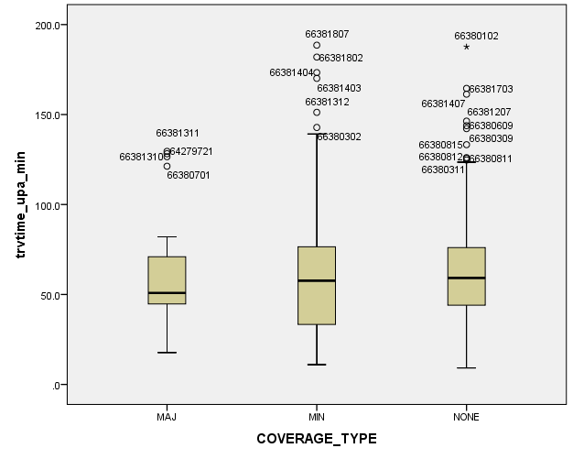

EXAMINE VARIABLES=trvtime_hspt_min BY COVERAGE_TYPE
/PLOT=BOXPLOT
/STATISTICS=NONE
/NOTOTAL
/ID=CODIGO_TXT.

Explore

Notes
Output Created |  | 13-MAR-2018 16:50:03
Comments
Input | Data | E:\Data_Final\3cases_traveltime.sav
Input | Active Dataset | DataSet1
Input | Filter | <none>
Input | Weight | <none>
Input | Split File | <none>
Input | N of Rows in Working Data File | 284
Missing Value Handling | Definition of Missing | User-defined missing values for dependent variables are treated as missing.
Missing Value Handling | Cases Used | Statistics are based on cases with no missing values for any dependent variable or factor used.
Syntax |  | EXAMINE VARIABLES=trvtime_hspt_min BY COVERAGE_TYPE  /PLOT=BOXPLOT  /STATISTICS=NONE  /NOTOTAL  /ID=CODIGO_TXT.
Resources | Processor Time | 00:00:00.19
Resources | Elapsed Time | 00:00:00.14

COVERAGE_TYPE

Case Processing Summary
 | COVERAGE_TYPE | Cases
 | COVERAGE_TYPE | Valid |  | Missing |  | Total
 | COVERAGE_TYPE | N | Percent | N | Percent | N
trvtime_hspt_min | MAJ | 50 | 96.2% | 2 | 3.8% | 52
trvtime_hspt_min | MIN | 85 | 94.4% | 5 | 5.6% | 90
trvtime_hspt_min | NONE | 137 | 96.5% | 5 | 3.5% | 142

Case Processing Summary
 | COVERAGE_TYPE | Cases
 | COVERAGE_TYPE | Total
 | COVERAGE_TYPE | Percent
trvtime_hspt_min | MAJ | 100.0%
trvtime_hspt_min | MIN | 100.0%
trvtime_hspt_min | NONE | 100.0%

trvtime_hspt_min

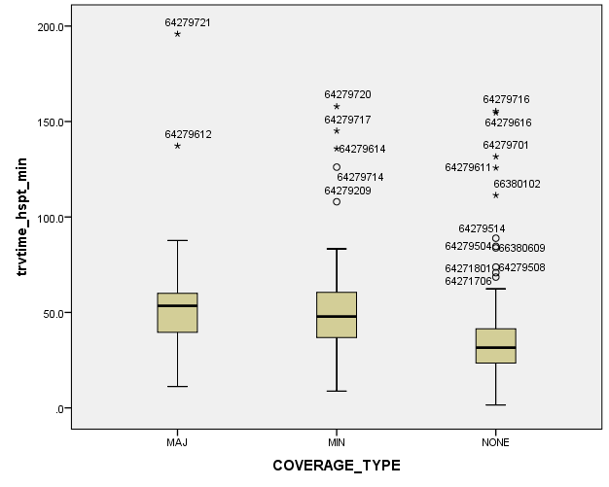

EXAMINE VARIABLES=trvtime_dgntrt_min BY COVERAGE_TYPE
/PLOT=BOXPLOT
/STATISTICS=NONE
/NOTOTAL
/ID=CODIGO_TXT.

Explore

Notes
Output Created |  | 13-MAR-2018 16:50:13
Comments
Input | Data | E:\Data_Final\3cases_traveltime.sav
Input | Active Dataset | DataSet1
Input | Filter | <none>
Input | Weight | <none>
Input | Split File | <none>
Input | N of Rows in Working Data File | 284
Missing Value Handling | Definition of Missing | User-defined missing values for dependent variables are treated as missing.
Missing Value Handling | Cases Used | Statistics are based on cases with no missing values for any dependent variable or factor used.
Syntax |  | EXAMINE VARIABLES=trvtime_dgntrt_min BY COVERAGE_TYPE  /PLOT=BOXPLOT  /STATISTICS=NONE  /NOTOTAL  /ID=CODIGO_TXT.
Resources | Processor Time | 00:00:00.31
Resources | Elapsed Time | 00:00:00.16

COVERAGE_TYPE

Case Processing Summary
 | COVERAGE_TYPE | Cases
 | COVERAGE_TYPE | Valid |  | Missing |  | Total
 | COVERAGE_TYPE | N | Percent | N | Percent | N
trvtime_dgntrt_min | MAJ | 52 | 100.0% | 0 | 0.0% | 52
trvtime_dgntrt_min | MIN | 90 | 100.0% | 0 | 0.0% | 90
trvtime_dgntrt_min | NONE | 140 | 98.6% | 2 | 1.4% | 142

Case Processing Summary
 | COVERAGE_TYPE | Cases
 | COVERAGE_TYPE | Total
 | COVERAGE_TYPE | Percent
trvtime_dgntrt_min | MAJ | 100.0%
trvtime_dgntrt_min | MIN | 100.0%
trvtime_dgntrt_min | NONE | 100.0%

trvtime_dgntrt_min

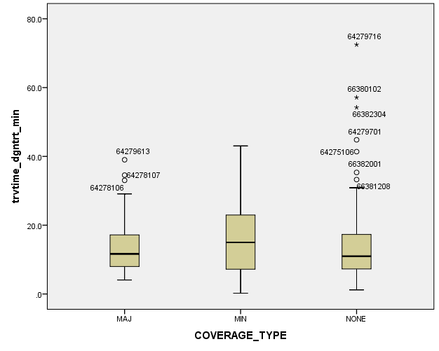

EXAMINE VARIABLES=trvtime_edknd_min BY COVERAGE_TYPE
/PLOT=BOXPLOT
/STATISTICS=NONE
/NOTOTAL
/ID=CODIGO_TXT.

Explore

Notes
Output Created |  | 13-MAR-2018 16:50:24
Comments
Input | Data | E:\Data_Final\3cases_traveltime.sav
Input | Active Dataset | DataSet1
Input | Filter | <none>
Input | Weight | <none>
Input | Split File | <none>
Input | N of Rows in Working Data File | 284
Missing Value Handling | Definition of Missing | User-defined missing values for dependent variables are treated as missing.
Missing Value Handling | Cases Used | Statistics are based on cases with no missing values for any dependent variable or factor used.
Syntax |  | EXAMINE VARIABLES=trvtime_edknd_min BY COVERAGE_TYPE  /PLOT=BOXPLOT  /STATISTICS=NONE  /NOTOTAL  /ID=CODIGO_TXT.
Resources | Processor Time | 00:00:00.19
Resources | Elapsed Time | 00:00:00.14

COVERAGE_TYPE

Case Processing Summary
 | COVERAGE_TYPE | Cases
 | COVERAGE_TYPE | Valid |  | Missing |  | Total
 | COVERAGE_TYPE | N | Percent | N | Percent | N
trvtime_edknd_min | MAJ | 52 | 100.0% | 0 | 0.0% | 52
trvtime_edknd_min | MIN | 90 | 100.0% | 0 | 0.0% | 90
trvtime_edknd_min | NONE | 142 | 100.0% | 0 | 0.0% | 142

Case Processing Summary
 | COVERAGE_TYPE | Cases
 | COVERAGE_TYPE | Total
 | COVERAGE_TYPE | Percent
trvtime_edknd_min | MAJ | 100.0%
trvtime_edknd_min | MIN | 100.0%
trvtime_edknd_min | NONE | 100.0%

trvtime_edknd_min

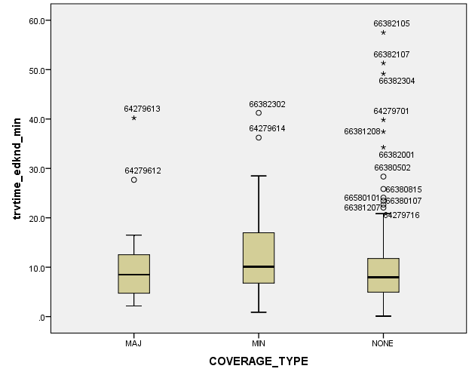

EXAMINE VARIABLES=trvtime_edprm_min BY COVERAGE_TYPE
/PLOT=BOXPLOT
/STATISTICS=NONE
/NOTOTAL
/ID=CODIGO_TXT.

Explore

Notes
Output Created |  | 13-MAR-2018 16:50:35
Comments
Input | Data | E:\Data_Final\3cases_traveltime.sav
Input | Active Dataset | DataSet1
Input | Filter | <none>
Input | Weight | <none>
Input | Split File | <none>
Input | N of Rows in Working Data File | 284
Missing Value Handling | Definition of Missing | User-defined missing values for dependent variables are treated as missing.
Missing Value Handling | Cases Used | Statistics are based on cases with no missing values for any dependent variable or factor used.
Syntax |  | EXAMINE VARIABLES=trvtime_edprm_min BY COVERAGE_TYPE  /PLOT=BOXPLOT  /STATISTICS=NONE  /NOTOTAL  /ID=CODIGO_TXT.
Resources | Processor Time | 00:00:00.19
Resources | Elapsed Time | 00:00:00.14

COVERAGE_TYPE

Case Processing Summary
 | COVERAGE_TYPE | Cases
 | COVERAGE_TYPE | Valid |  | Missing |  | Total
 | COVERAGE_TYPE | N | Percent | N | Percent | N
trvtime_edprm_min | MAJ | 52 | 100.0% | 0 | 0.0% | 52
trvtime_edprm_min | MIN | 90 | 100.0% | 0 | 0.0% | 90
trvtime_edprm_min | NONE | 142 | 100.0% | 0 | 0.0% | 142

Case Processing Summary
 | COVERAGE_TYPE | Cases
 | COVERAGE_TYPE | Total
 | COVERAGE_TYPE | Percent
trvtime_edprm_min | MAJ | 100.0%
trvtime_edprm_min | MIN | 100.0%
trvtime_edprm_min | NONE | 100.0%

trvtime_edprm_min

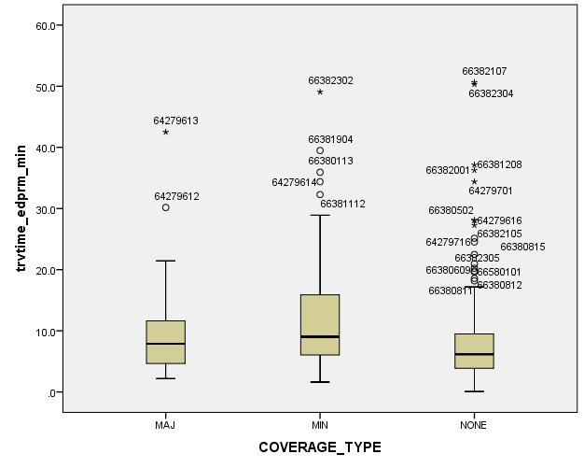

EXAMINE VARIABLES=trvtime_edsec_min BY COVERAGE_TYPE
/PLOT=BOXPLOT
/STATISTICS=NONE
/NOTOTAL
/ID=CODIGO_TXT.

Explore

Notes
Output Created |  | 13-MAR-2018 16:50:51
Comments
Input | Data | E:\Data_Final\3cases_traveltime.sav
Input | Active Dataset | DataSet1
Input | Filter | <none>
Input | Weight | <none>
Input | Split File | <none>
Input | N of Rows in Working Data File | 284
Missing Value Handling | Definition of Missing | User-defined missing values for dependent variables are treated as missing.
Missing Value Handling | Cases Used | Statistics are based on cases with no missing values for any dependent variable or factor used.
Syntax |  | EXAMINE VARIABLES=trvtime_edsec_min BY COVERAGE_TYPE  /PLOT=BOXPLOT  /STATISTICS=NONE  /NOTOTAL  /ID=CODIGO_TXT.
Resources | Processor Time | 00:00:00.17
Resources | Elapsed Time | 00:00:00.16

COVERAGE_TYPE

Case Processing Summary
 | COVERAGE_TYPE | Cases
 | COVERAGE_TYPE | Valid |  | Missing |  | Total
 | COVERAGE_TYPE | N | Percent | N | Percent | N
trvtime_edsec_min | MAJ | 52 | 100.0% | 0 | 0.0% | 52
trvtime_edsec_min | MIN | 90 | 100.0% | 0 | 0.0% | 90
trvtime_edsec_min | NONE | 142 | 100.0% | 0 | 0.0% | 142

Case Processing Summary
 | COVERAGE_TYPE | Cases
 | COVERAGE_TYPE | Total
 | COVERAGE_TYPE | Percent
trvtime_edsec_min | MAJ | 100.0%
trvtime_edsec_min | MIN | 100.0%
trvtime_edsec_min | NONE | 100.0%

trvtime_edsec_min

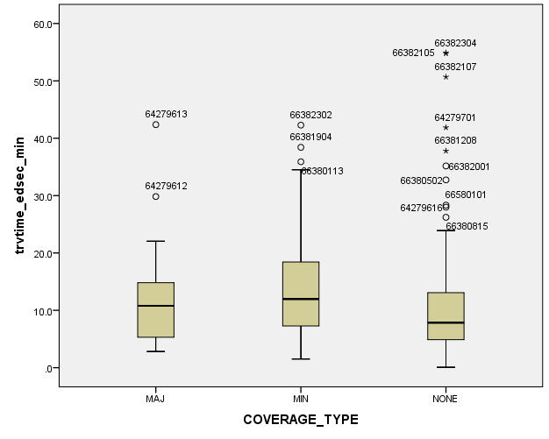

GET
FILE='E:\Data_Final\pilar_traveltime.sav'.
DATASET NAME DataSet2 WINDOW=FRONT.
DATASET ACTIVATE DataSet1.
DATASET ACTIVATE DataSet1.

SAVE OUTFILE='E:\Data_Final\3cases_traveltime.sav'
/COMPRESSED.
DATASET ACTIVATE DataSet1.
DATASET CLOSE DataSet2.
GRAPH
/HISTOGRAM=trvtime_cbd_bsas
/PANEL ROWVAR=COVERAGE_TYPE ROWOP=CROSS.

Graph

Notes
Output Created |  | 13-MAR-2018 16:52:14
Comments
Input | Data | E:\Data_Final\3cases_traveltime.sav
Input | Active Dataset | DataSet1
Input | Filter | <none>
Input | Weight | <none>
Input | Split File | <none>
Input | N of Rows in Working Data File | 284
Syntax |  | GRAPH  /HISTOGRAM=trvtime_cbd_bsas  /PANEL ROWVAR=COVERAGE_TYPE ROWOP=CROSS.
Resources | Processor Time | 00:00:00.20
Resources | Elapsed Time | 00:00:00.17

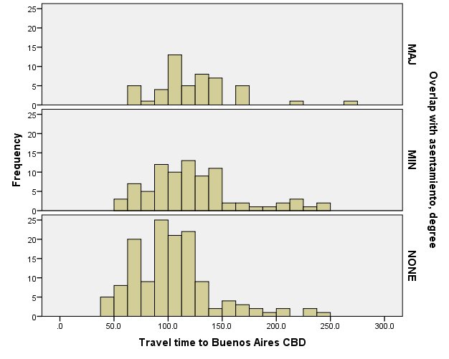

GRAPH
/HISTOGRAM(NORMAL)=trvtime_cbd_bsas
/PANEL ROWVAR=COVERAGE_TYPE ROWOP=CROSS.

Graph

Notes
Output Created |  | 13-MAR-2018 16:52:24
Comments
Input | Data | E:\Data_Final\3cases_traveltime.sav
Input | Active Dataset | DataSet1
Input | Filter | <none>
Input | Weight | <none>
Input | Split File | <none>
Input | N of Rows in Working Data File | 284
Syntax |  | GRAPH  /HISTOGRAM(NORMAL)=trvtime_cbd_bsas  /PANEL ROWVAR=COVERAGE_TYPE ROWOP=CROSS.
Resources | Processor Time | 00:00:00.17
Resources | Elapsed Time | 00:00:00.14

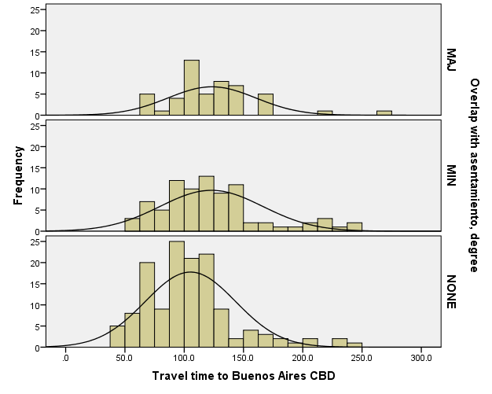

GRAPH
/HISTOGRAM(NORMAL)=trvtime_cbd_loc
/PANEL ROWVAR=COVERAGE_TYPE ROWOP=CROSS.

Graph

Notes
Output Created |  | 13-MAR-2018 16:52:39
Comments
Input | Data | E:\Data_Final\3cases_traveltime.sav
Input | Active Dataset | DataSet1
Input | Filter | <none>
Input | Weight | <none>
Input | Split File | <none>
Input | N of Rows in Working Data File | 284
Syntax |  | GRAPH  /HISTOGRAM(NORMAL)=trvtime_cbd_loc  /PANEL ROWVAR=COVERAGE_TYPE ROWOP=CROSS.
Resources | Processor Time | 00:00:00.22
Resources | Elapsed Time | 00:00:00.14

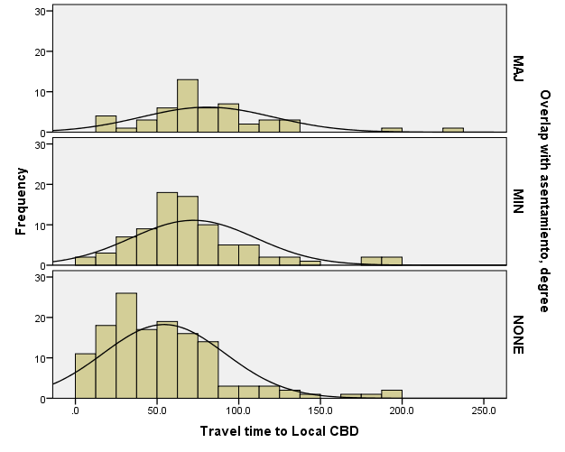

GRAPH
/HISTOGRAM(NORMAL)=trvtime_cbd_ngh_min
/PANEL ROWVAR=COVERAGE_TYPE ROWOP=CROSS.

Graph

Notes
Output Created |  | 13-MAR-2018 16:52:53
Comments
Input | Data | E:\Data_Final\3cases_traveltime.sav
Input | Active Dataset | DataSet1
Input | Filter | <none>
Input | Weight | <none>
Input | Split File | <none>
Input | N of Rows in Working Data File | 284
Syntax |  | GRAPH  /HISTOGRAM(NORMAL)=trvtime_cbd_ngh_min  /PANEL ROWVAR=COVERAGE_TYPE ROWOP=CROSS.
Resources | Processor Time | 00:00:00.16
Resources | Elapsed Time | 00:00:00.14

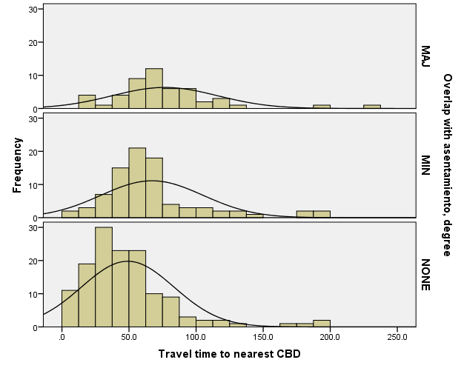

GRAPH
/HISTOGRAM(NORMAL)=trvtime_rail_min
/PANEL ROWVAR=COVERAGE_TYPE ROWOP=CROSS.

Graph

Notes
Output Created |  | 13-MAR-2018 16:53:07
Comments
Input | Data | E:\Data_Final\3cases_traveltime.sav
Input | Active Dataset | DataSet1
Input | Filter | <none>
Input | Weight | <none>
Input | Split File | <none>
Input | N of Rows in Working Data File | 284
Syntax |  | GRAPH  /HISTOGRAM(NORMAL)=trvtime_rail_min  /PANEL ROWVAR=COVERAGE_TYPE ROWOP=CROSS.
Resources | Processor Time | 00:00:00.17
Resources | Elapsed Time | 00:00:00.13

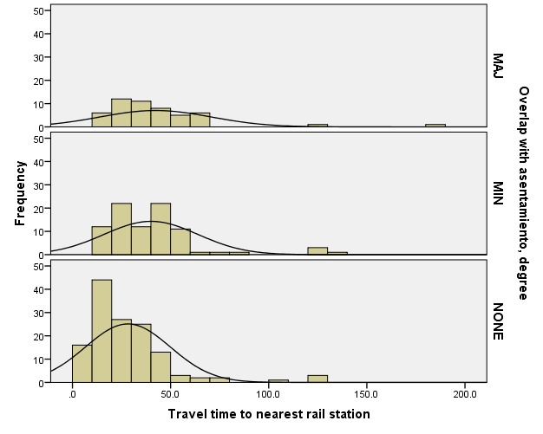

GRAPH
/HISTOGRAM(NORMAL)=trvtime_upa_min
/PANEL ROWVAR=COVERAGE_TYPE ROWOP=CROSS.

Graph

Notes
Output Created |  | 13-MAR-2018 16:53:17
Comments
Input | Data | E:\Data_Final\3cases_traveltime.sav
Input | Active Dataset | DataSet1
Input | Filter | <none>
Input | Weight | <none>
Input | Split File | <none>
Input | N of Rows in Working Data File | 284
Syntax |  | GRAPH  /HISTOGRAM(NORMAL)=trvtime_upa_min  /PANEL ROWVAR=COVERAGE_TYPE ROWOP=CROSS.
Resources | Processor Time | 00:00:00.16
Resources | Elapsed Time | 00:00:00.14

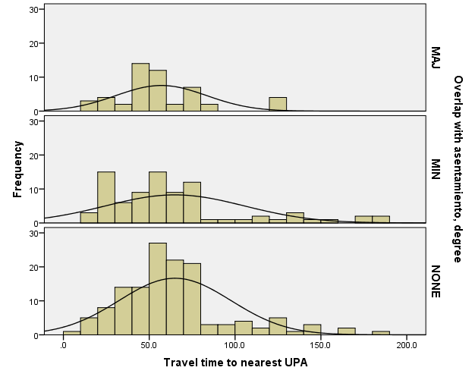

GRAPH
/HISTOGRAM(NORMAL)=trvtime_hspt_min
/PANEL ROWVAR=COVERAGE_TYPE ROWOP=CROSS.

Graph

Notes
Output Created |  | 13-MAR-2018 16:53:30
Comments
Input | Data | E:\Data_Final\3cases_traveltime.sav
Input | Active Dataset | DataSet1
Input | Filter | <none>
Input | Weight | <none>
Input | Split File | <none>
Input | N of Rows in Working Data File | 284
Syntax |  | GRAPH  /HISTOGRAM(NORMAL)=trvtime_hspt_min  /PANEL ROWVAR=COVERAGE_TYPE ROWOP=CROSS.
Resources | Processor Time | 00:00:00.16
Resources | Elapsed Time | 00:00:00.14

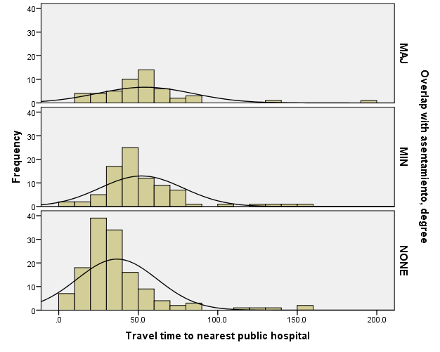

GRAPH
/HISTOGRAM(NORMAL)=trvtime_dgntrt_min
/PANEL ROWVAR=COVERAGE_TYPE ROWOP=CROSS.

Graph

Notes
Output Created |  | 13-MAR-2018 16:53:54
Comments
Input | Data | E:\Data_Final\3cases_traveltime.sav
Input | Active Dataset | DataSet1
Input | Filter | <none>
Input | Weight | <none>
Input | Split File | <none>
Input | N of Rows in Working Data File | 284
Syntax |  | GRAPH  /HISTOGRAM(NORMAL)=trvtime_dgntrt_min  /PANEL ROWVAR=COVERAGE_TYPE ROWOP=CROSS.
Resources | Processor Time | 00:00:00.14
Resources | Elapsed Time | 00:00:00.13

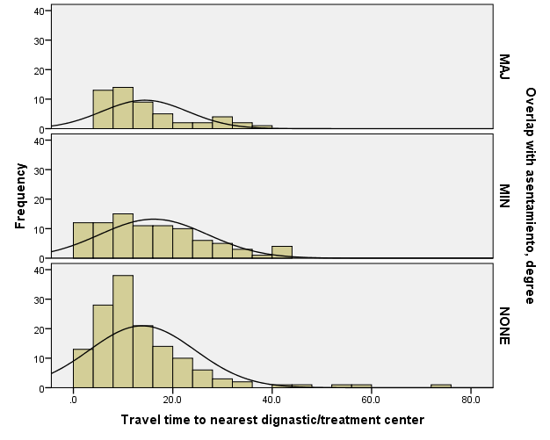

GRAPH
/HISTOGRAM(NORMAL)=trvtime_edsec_min
/PANEL ROWVAR=COVERAGE_TYPE ASENTANY_YN ROWOP=CROSS.

Graph

Notes
Output Created |  | 13-MAR-2018 16:54:20
Comments
Input | Data | E:\Data_Final\3cases_traveltime.sav
Input | Active Dataset | DataSet1
Input | Filter | <none>
Input | Weight | <none>
Input | Split File | <none>
Input | N of Rows in Working Data File | 284
Syntax |  | GRAPH  /HISTOGRAM(NORMAL)=trvtime_edsec_min  /PANEL ROWVAR=COVERAGE_TYPE ASENTANY_YN ROWOP=CROSS.
Resources | Processor Time | 00:00:00.16
Resources | Elapsed Time | 00:00:00.14

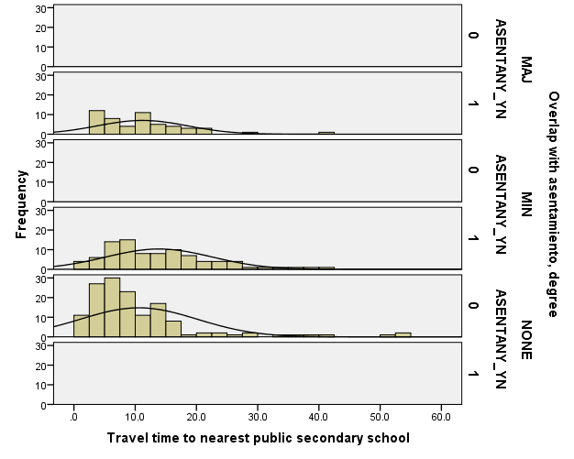

GRAPH
/HISTOGRAM(NORMAL)=trvtime_edsec_min
/PANEL ROWVAR=COVERAGE_TYPE ROWOP=CROSS.

Graph

Notes
Output Created |  | 13-MAR-2018 16:54:29
Comments
Input | Data | E:\Data_Final\3cases_traveltime.sav
Input | Active Dataset | DataSet1
Input | Filter | <none>
Input | Weight | <none>
Input | Split File | <none>
Input | N of Rows in Working Data File | 284
Syntax |  | GRAPH  /HISTOGRAM(NORMAL)=trvtime_edsec_min  /PANEL ROWVAR=COVERAGE_TYPE ROWOP=CROSS.
Resources | Processor Time | 00:00:00.16
Resources | Elapsed Time | 00:00:00.14

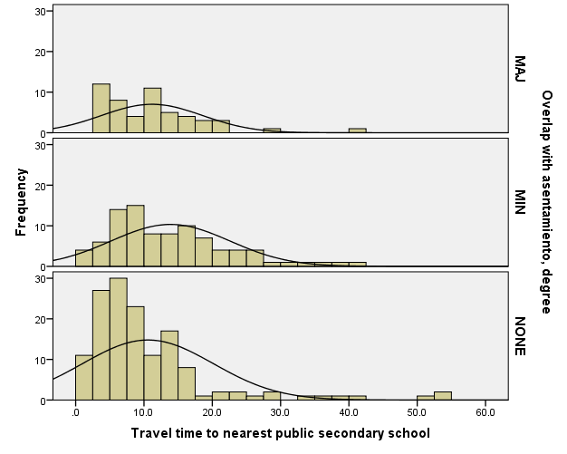

GRAPH
/HISTOGRAM(NORMAL)=trvtime_edprm_min
/PANEL ROWVAR=COVERAGE_TYPE ROWOP=CROSS.

Graph

Notes
Output Created |  | 13-MAR-2018 16:54:41
Comments
Input | Data | E:\Data_Final\3cases_traveltime.sav
Input | Active Dataset | DataSet1
Input | Filter | <none>
Input | Weight | <none>
Input | Split File | <none>
Input | N of Rows in Working Data File | 284
Syntax |  | GRAPH  /HISTOGRAM(NORMAL)=trvtime_edprm_min  /PANEL ROWVAR=COVERAGE_TYPE ROWOP=CROSS.
Resources | Processor Time | 00:00:00.14
Resources | Elapsed Time | 00:00:00.14

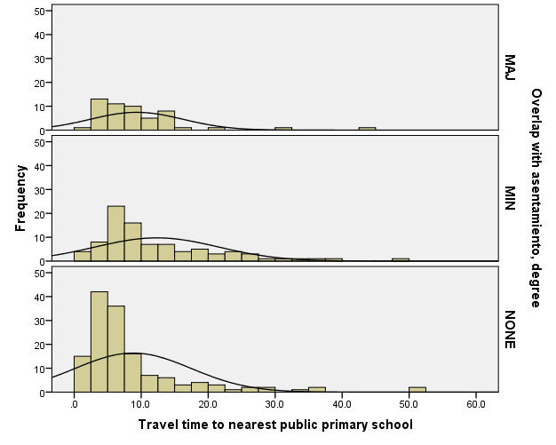

GRAPH
/HISTOGRAM(NORMAL)=trvtime_edknd_min
/PANEL ROWVAR=COVERAGE_TYPE ROWOP=CROSS.

Graph

Notes
Output Created |  | 13-MAR-2018 16:54:50
Comments
Input | Data | E:\Data_Final\3cases_traveltime.sav
Input | Active Dataset | DataSet1
Input | Filter | <none>
Input | Weight | <none>
Input | Split File | <none>
Input | N of Rows in Working Data File | 284
Syntax |  | GRAPH  /HISTOGRAM(NORMAL)=trvtime_edknd_min  /PANEL ROWVAR=COVERAGE_TYPE ROWOP=CROSS.
Resources | Processor Time | 00:00:00.19
Resources | Elapsed Time | 00:00:00.14

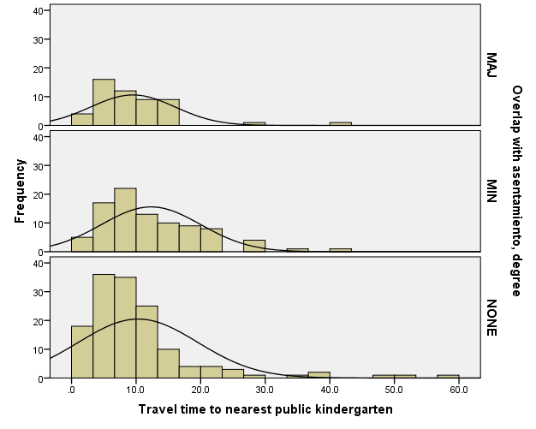

DATASET ACTIVATE DataSet1.

SAVE OUTFILE='E:\Data_Final\3cases_traveltime.sav'
/COMPRESSED.
GRAPH
/HISTOGRAM(NORMAL)=trvtime_cbd_bsas
/PANEL ROWVAR=ASENTANY_YN ROWOP=CROSS.

Graph

Notes
Output Created |  | 13-MAR-2018 16:55:25
Comments
Input | Data | E:\Data_Final\3cases_traveltime.sav
Input | Active Dataset | DataSet1
Input | Filter | <none>
Input | Weight | <none>
Input | Split File | <none>
Input | N of Rows in Working Data File | 284
Syntax |  | GRAPH  /HISTOGRAM(NORMAL)=trvtime_cbd_bsas  /PANEL ROWVAR=ASENTANY_YN ROWOP=CROSS.
Resources | Processor Time | 00:00:00.13
Resources | Elapsed Time | 00:00:00.13

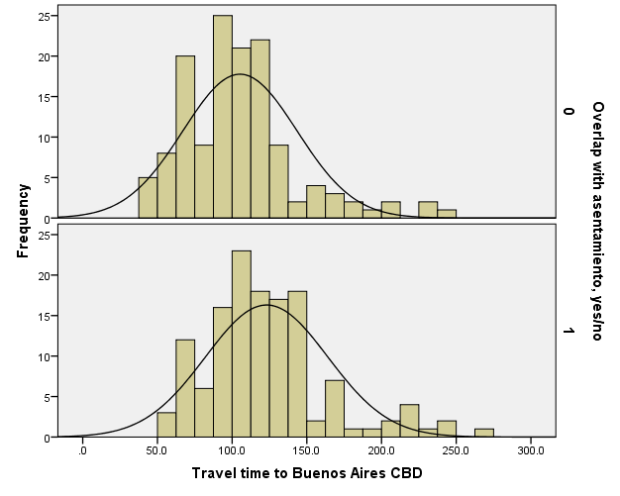

GRAPH
/HISTOGRAM(NORMAL)=trvtime_cbd_loc
/PANEL ROWVAR=ASENTANY_YN ROWOP=CROSS.

Graph

Notes
Output Created |  | 13-MAR-2018 16:55:38
Comments
Input | Data | E:\Data_Final\3cases_traveltime.sav
Input | Active Dataset | DataSet1
Input | Filter | <none>
Input | Weight | <none>
Input | Split File | <none>
Input | N of Rows in Working Data File | 284
Syntax |  | GRAPH  /HISTOGRAM(NORMAL)=trvtime_cbd_loc  /PANEL ROWVAR=ASENTANY_YN ROWOP=CROSS.
Resources | Processor Time | 00:00:00.16
Resources | Elapsed Time | 00:00:00.14

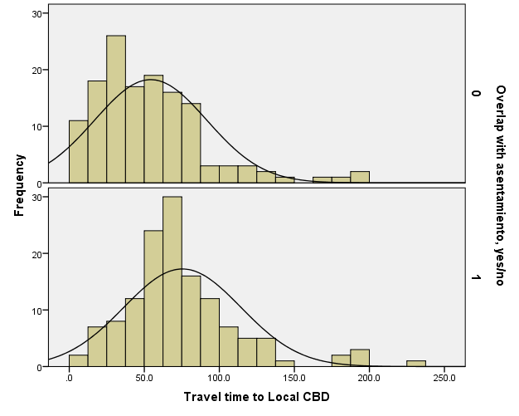

GRAPH
/HISTOGRAM(NORMAL)=trvtime_cbd_ngh_min
/PANEL ROWVAR=ASENTANY_YN ROWOP=CROSS.

Graph

Notes
Output Created |  | 13-MAR-2018 16:55:50
Comments
Input | Data | E:\Data_Final\3cases_traveltime.sav
Input | Active Dataset | DataSet1
Input | Filter | <none>
Input | Weight | <none>
Input | Split File | <none>
Input | N of Rows in Working Data File | 284
Syntax |  | GRAPH  /HISTOGRAM(NORMAL)=trvtime_cbd_ngh_min  /PANEL ROWVAR=ASENTANY_YN ROWOP=CROSS.
Resources | Processor Time | 00:00:00.13
Resources | Elapsed Time | 00:00:00.13

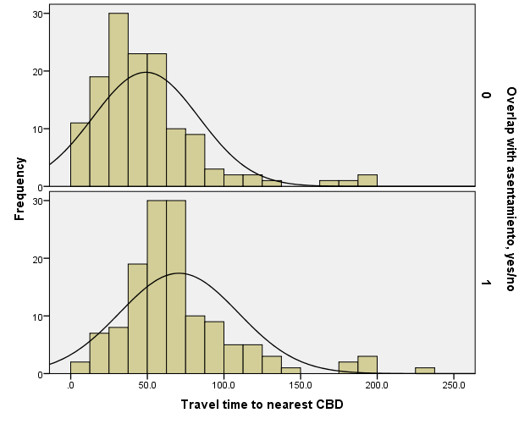

GRAPH
/HISTOGRAM(NORMAL)=trvtime_rail_min
/PANEL ROWVAR=ASENTANY_YN ROWOP=CROSS.

Graph

Notes
Output Created |  | 13-MAR-2018 16:56:10
Comments
Input | Data | E:\Data_Final\3cases_traveltime.sav
Input | Active Dataset | DataSet1
Input | Filter | <none>
Input | Weight | <none>
Input | Split File | <none>
Input | N of Rows in Working Data File | 284
Syntax |  | GRAPH  /HISTOGRAM(NORMAL)=trvtime_rail_min  /PANEL ROWVAR=ASENTANY_YN ROWOP=CROSS.
Resources | Processor Time | 00:00:00.33
Resources | Elapsed Time | 00:00:00.17

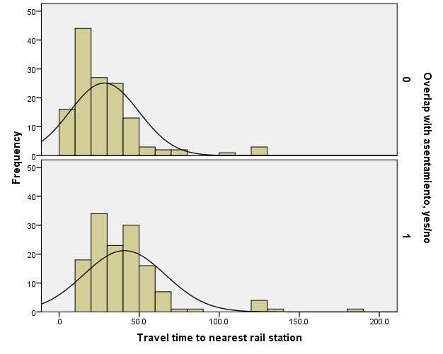

GRAPH
/HISTOGRAM(NORMAL)=trvtime_upa_min
/PANEL ROWVAR=ASENTANY_YN ROWOP=CROSS.

Graph

Notes
Output Created |  | 13-MAR-2018 16:56:22
Comments
Input | Data | E:\Data_Final\3cases_traveltime.sav
Input | Active Dataset | DataSet1
Input | Filter | <none>
Input | Weight | <none>
Input | Split File | <none>
Input | N of Rows in Working Data File | 284
Syntax |  | GRAPH  /HISTOGRAM(NORMAL)=trvtime_upa_min  /PANEL ROWVAR=ASENTANY_YN ROWOP=CROSS.
Resources | Processor Time | 00:00:00.16
Resources | Elapsed Time | 00:00:00.13

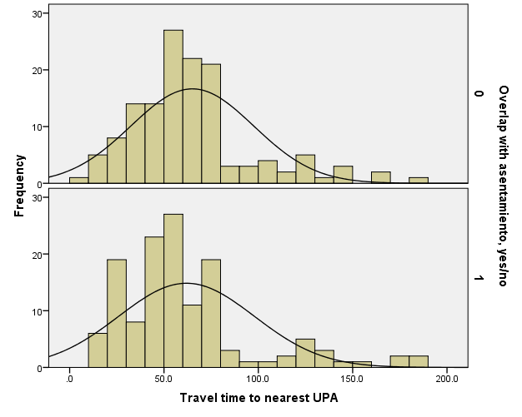

GRAPH
/HISTOGRAM(NORMAL)=trvtime_hspt_min
/PANEL ROWVAR=ASENTANY_YN ROWOP=CROSS.

Graph

Notes
Output Created |  | 13-MAR-2018 16:56:31
Comments
Input | Data | E:\Data_Final\3cases_traveltime.sav
Input | Active Dataset | DataSet1
Input | Filter | <none>
Input | Weight | <none>
Input | Split File | <none>
Input | N of Rows in Working Data File | 284
Syntax |  | GRAPH  /HISTOGRAM(NORMAL)=trvtime_hspt_min  /PANEL ROWVAR=ASENTANY_YN ROWOP=CROSS.
Resources | Processor Time | 00:00:00.13
Resources | Elapsed Time | 00:00:00.13

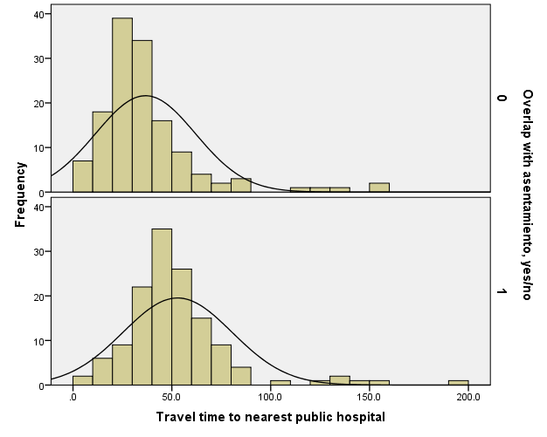

GRAPH
/HISTOGRAM(NORMAL)=trvtime_dgntrt_min
/PANEL ROWVAR=ASENTANY_YN ROWOP=CROSS.

Graph

Notes
Output Created |  | 13-MAR-2018 16:56:42
Comments
Input | Data | E:\Data_Final\3cases_traveltime.sav
Input | Active Dataset | DataSet1
Input | Filter | <none>
Input | Weight | <none>
Input | Split File | <none>
Input | N of Rows in Working Data File | 284
Syntax |  | GRAPH  /HISTOGRAM(NORMAL)=trvtime_dgntrt_min  /PANEL ROWVAR=ASENTANY_YN ROWOP=CROSS.
Resources | Processor Time | 00:00:00.14
Resources | Elapsed Time | 00:00:00.13

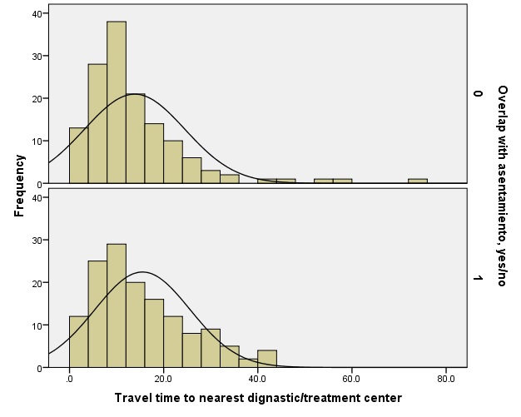

GRAPH
/HISTOGRAM(NORMAL)=trvtime_edsec_min
/PANEL ROWVAR=ASENTANY_YN ROWOP=CROSS.

Graph

Notes
Output Created |  | 13-MAR-2018 16:56:50
Comments
Input | Data | E:\Data_Final\3cases_traveltime.sav
Input | Active Dataset | DataSet1
Input | Filter | <none>
Input | Weight | <none>
Input | Split File | <none>
Input | N of Rows in Working Data File | 284
Syntax |  | GRAPH  /HISTOGRAM(NORMAL)=trvtime_edsec_min  /PANEL ROWVAR=ASENTANY_YN ROWOP=CROSS.
Resources | Processor Time | 00:00:00.14
Resources | Elapsed Time | 00:00:00.13

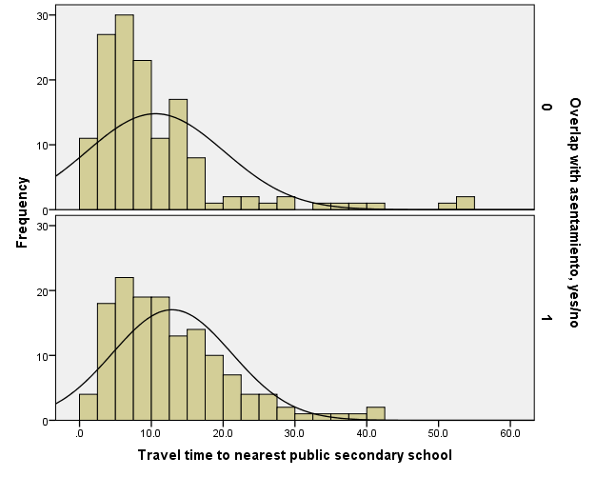

GRAPH
/HISTOGRAM(NORMAL)=trvtime_edprm_min
/PANEL ROWVAR=ASENTANY_YN ROWOP=CROSS.

Graph

Notes
Output Created |  | 13-MAR-2018 16:57:03
Comments
Input | Data | E:\Data_Final\3cases_traveltime.sav
Input | Active Dataset | DataSet1
Input | Filter | <none>
Input | Weight | <none>
Input | Split File | <none>
Input | N of Rows in Working Data File | 284
Syntax |  | GRAPH  /HISTOGRAM(NORMAL)=trvtime_edprm_min  /PANEL ROWVAR=ASENTANY_YN ROWOP=CROSS.
Resources | Processor Time | 00:00:00.14
Resources | Elapsed Time | 00:00:00.14

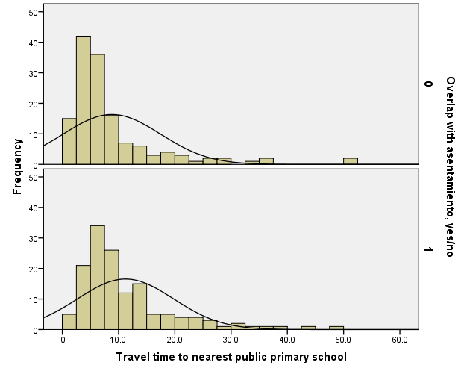

GRAPH
/HISTOGRAM(NORMAL)=trvtime_edknd_min
/PANEL ROWVAR=ASENTANY_YN ROWOP=CROSS.

Graph

Notes
Output Created |  | 13-MAR-2018 16:57:11
Comments
Input | Data | E:\Data_Final\3cases_traveltime.sav
Input | Active Dataset | DataSet1
Input | Filter | <none>
Input | Weight | <none>
Input | Split File | <none>
Input | N of Rows in Working Data File | 284
Syntax |  | GRAPH  /HISTOGRAM(NORMAL)=trvtime_edknd_min  /PANEL ROWVAR=ASENTANY_YN ROWOP=CROSS.
Resources | Processor Time | 00:00:00.16
Resources | Elapsed Time | 00:00:00.14

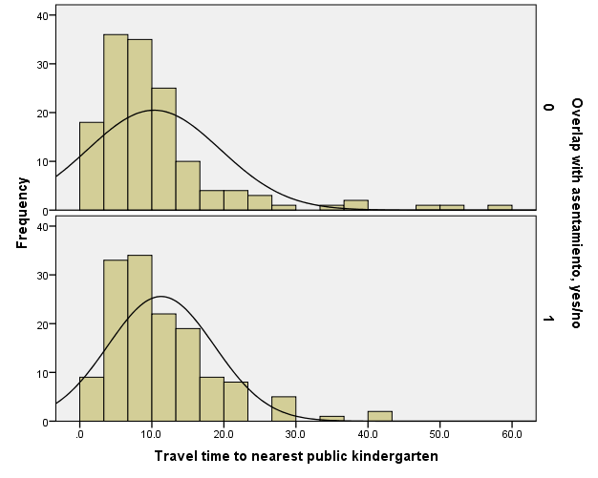

EXAMINE VARIABLES=trvtime_cbd_bsas BY ASENTANY_YN
/PLOT=BOXPLOT
/STATISTICS=NONE
/NOTOTAL
/ID=CODIGO_TXT.

Explore

Notes
Output Created |  | 13-MAR-2018 16:57:37
Comments
Input | Data | E:\Data_Final\3cases_traveltime.sav
Input | Active Dataset | DataSet1
Input | Filter | <none>
Input | Weight | <none>
Input | Split File | <none>
Input | N of Rows in Working Data File | 284
Missing Value Handling | Definition of Missing | User-defined missing values for dependent variables are treated as missing.
Missing Value Handling | Cases Used | Statistics are based on cases with no missing values for any dependent variable or factor used.
Syntax |  | EXAMINE VARIABLES=trvtime_cbd_bsas BY ASENTANY_YN  /PLOT=BOXPLOT  /STATISTICS=NONE  /NOTOTAL  /ID=CODIGO_TXT.
Resources | Processor Time | 00:00:00.16
Resources | Elapsed Time | 00:00:00.13

Overlap with asentamiento, yes/no

Case Processing Summary
 | Overlap with asentamiento, yes/no | Cases
 | Overlap with asentamiento, yes/no | Valid |  | Missing
 | Overlap with asentamiento, yes/no | N | Percent | N | Percent
Travel time to Buenos Aires CBD | 0 | 136 | 95.8% | 6 | 4.2%
Travel time to Buenos Aires CBD | 1 | 134 | 94.4% | 8 | 5.6%

Case Processing Summary
 | Overlap with asentamiento, yes/no | Cases
 | Overlap with asentamiento, yes/no | Total
 | Overlap with asentamiento, yes/no | N | Percent
Travel time to Buenos Aires CBD | 0 | 142 | 100.0%
Travel time to Buenos Aires CBD | 1 | 142 | 100.0%

Travel time to Buenos Aires CBD

